**Route Groups**

***Work-flow to Use Route Groups***

Use **Add Preference** to obtain a baseline dialog that sets a named Route Group



Repeat **Add Preference** for additional instances of the baseline dialog



***Preference Overview***

This preference sets up named Route Groups.

***Add Preference Dialog***

**Prerequisites:** None.

**Opening Dialog:**

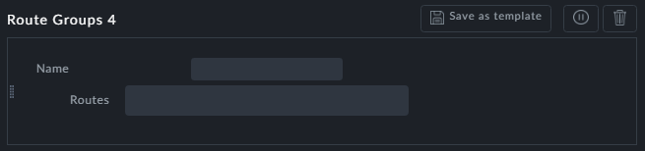

**Points to note:**

**Name**: Enter a name for the group. The name will be used in reports. Further, they will be available by name to preferences requiring Route Groups.



**Routes**: You will be shown a drop-down list of available routes.

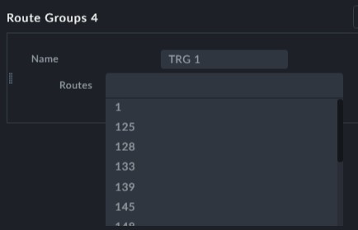

Choose as many as you need by clicking them.

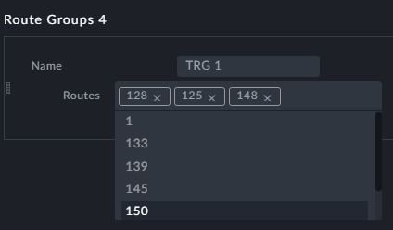

You may use **Add Preferences** to create additional Route Groups

